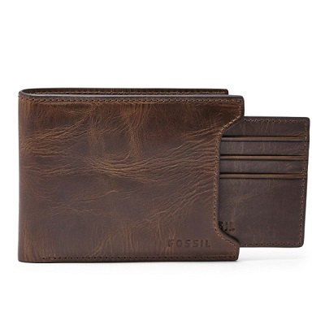

DERRICK SLIDING 2-IN-1

PRODUCT DETAILS

**Silhouette: Bifold**

**Exterior Material: 100% Leather**

**Interior Details: 8 Credit Card Slots, 2 Slip Pockets, 1 Bill Compartment**

**Measurements: 4.5"L x 0.75"W x 3.5"H**

**Warranty: 1 Year Limited**